Supplemental CAL FIRE BWD Budgeting Guidelines

Forest Business Alliance

18 March 2025

The Forest Business Alliance (FBA) created the templates and guidelines in this workbook to help grant seekers prepare budgets that: 1) meet the requirements of the California Department of Forestry and Fire Protection’s (CAL FIRE) Wood Products and Bioenergy Business and Workforce Development FY 2024-2025 Grant Guidelines; 2) facilitate project design and management; and 3) make it relatively easy to upload information into the e-Civis budget portal.

This document is intended to supplement and clarify guidance provided by CAL FIRE and e-Civis. Should any conflict exist between this document and CAL FIRE’s FY2024-2025 Grant Guidelines or the e-Civis Portal Applicant User Guide, the guidelines provided by CAL FIRE and e-Civis supersede any guidance or suggestions provided herein. Additionally, please note that applicants are not required to use the FBA templates to prepare their budgets, and applicants must submit their final budgets through the e-Civis portal.

For more information and templates go to forestbusinessalliance.org or get in touch with us at forestbusinessalliance@gmail.com.

Step 1.a. Instructions

The Instructions worksheet contains the document you are presently reading. It is included in the budget workbook to ensure it is easily accessible as you prepare your budget.

Step 1.b. Eligible Costs

The worksheet titled Step 1.b. Eligible Costs lists the eligible and ineligible costs contained on pages 22 through 25 of CAL FIRE’s FY 2024-2025 Grant Guidelines. Please read CAL FIRE’s descriptions of eligible and ineligible costs carefully before starting your budget. Important points to consider include:

- All costs included in the budget must be considered reasonable and necessary for the completion of the project.

- Only include salaries and wages (and fringe benefits) of personnel employed by the grantee who are DIRECTLY engaged in the execution of the project. Time charged to the grant is limited to actual time spent on the project.

- Consultants and contracted services must be necessary to achieve grant objectives. Furthermore, they must be selected using a competitive procurement process that includes price analysis.

- Supplies used in direct support of the project are allowable. Items with a unit cost exceeding $500 must be procured on a competitive basis and price analysis must be documented.

- Equipment/infrastructure is defined as any item worth $5,000 or more per unit and has a tangible useful life or more than one year. CAL FIRE allows equipment to be leased. Procurement processes must be competitive.

- Workforce development projects managed by non-profit grantees are the only project types eligible for indirect charges. Indirect charges must not exceed 12% for eligible projects unless an exemption is granted by CAL FIRE.

- Indirect charges shall not be applied to equipment purchases or business development projects.

Step 2. Inflation Calculator

The e-Civis portal does not allow the user to insert costs by project year. Therefore, for multi-year projects, to ensure your unit cost is adequate to cover the actual cost of project expenses after year 1, you may wish to use this tool to calculate an average unit cost over the life of the award. The worksheet is organized by budget category. Only input information into green and yellow cells. White cells calculate automatically.

Follow these steps:

- Input multi-year costs into their respective cost categories. Line-item descriptions go into Column A and their units of measure and unit costs will go into columns B and C, respectively.

- Input the anticipated annual inflation rate into cell C6.

- Input your organization’s fringe benefit rate into cell C29.

- In column I, for each budget line, input the number of years the cost will be incurred.

Once you have completed these four steps, the worksheet will calculate the average unit costs for you in column J. Use these unit costs when completing Step 3.

Step 3. Detailed Budget

The budget template provided in Step 3 is intended to help grantees develop a detailed budget that will be useful for project planning and implementation, while also generating the information in a format that will facilitate completion of the e-Civis budget portal.

The template was designed for projects lasting up to four years because page 7 of the CAL FIRE’s FY 2024-2025 Grant Guidelines indicates that “This solicitation requires grant projects to be completed by March 31, 2029.”

Instructions for Step 3 are listed in the order they appear in the template. You will use the information you generated in Step 2 to complete Step 3, inputting the costs from these sheets into appropriate budget categories. Please remember to only input information into green and yellow cells. White cells calculate automatically.

General Budgeting Procedure

- Column A, Title of Line Item: Use column A to provide descriptions that clearly communicate to CAL FIRE what you are budgeting. Be as specific as possible while also being concise. You will be able to provide additional details in the budget narrative.

- Column B, Description (Unit of Measure): In Column B, input the unit that best describes the cost. The template contains pulldown menus for common units of measure for each budget category. If none of the units contained in the pulldown menu adequately describe the item you have budged, choose “Other Unit”.

- Column C, Unit Cost: Column C is used to input the cost of the unit used in column B. For multi-year projects, remember to use the inflation-adjusted unit costs calculated in Step 2.

- Column D, GL Code: This column is used to record the General Ledger Code of the budgeted cost. It is intended to help the grantee track costs during implementation. The e-Civis portal allows users to input this information, but it is not required.

- Columns E, G, K, M, Q, S, W, and Y, # Units: These columns are used to input the number of units required for each line item. Columns E, K, Q, and W should be used for the number of units that will be covered by CAL FIRE grant funds. Columns G, M, S, and Y should be used to input any unit that will be covered as cost share (matching funds).

Salaries and Wages

List the position titles for all the staff who will dedicate time to the proposed project. Please note that consultants should not be included here. You will include them under the Contractual category of the budget template. Typically, the unit of measure for personnel is either month or year. For the unit cost, input the employee’s monthly or annual pay rate excluding fringe benefits, which will be calculated separately in the following section.

Please note that applicants are responsible for budgeting for prevailing wages when applicable. CAL FIRE provides no opinion as to whether projects may be subject to California’s prevailing wage requirement. According to the State of California’s Department of Industrial Relations, “All workers employed on public works projects must be paid the prevailing wage determined by the Director of the Department of Industrial Relations, according to the type of work and location of the project. The prevailing wage rates are usually based on rates specified in collective bargaining agreements.” To learn more about prevailing wages, please refer to the Department of Industrial Relations’ webpage on this topic and/or contact the agency.

Fringe Benefits

Many organizations have an established fringe benefit rate for their employees. The benefit rate typically includes Social Security, Medicare, Health Insurance, Pension Plan costs, etc. as applicable for the specific employee, but may include fewer or more benefits.

Insert your organization’s fringe benefit rate into cell C28. Once you do so, Columns A, B and C will populate automatically using this rate and the information you provided in the Salaries and Wages section of the template.

If your organization’s fringe rate varies by employee, you will need to manually adjust the fringe rate in column C. To do so, you will need to unprotect the worksheet.

Contractual

The Contractual section should be used to budget consultants and contracts with service providers. Proceed with costing the Contractual section of the template by following the general budgeting procedure. For consultants, in the # Units columns, grantees typically input the number of days they will dedicate to the project per year. However, it is also possible to use the cost of a negotiated, fixed-term contract. The same is true for service providers. Contractors’ supplies and travel costs must also be budgeted under this category.

Travel

Think about what travel you will need to do to successfully implement the project. Do your best to break out the costs in a manner that will make it easy for others to understand. For instance, if you are budgeting quarterly site visits, you could break down the costs into vehicle mileage, hotel and per diem. Anybody can easily see how these were calculated by looking at the line-item description, unit cost, and number of units. Costing in this way makes it easier to prepare your budget narrative, and it helps ensure that your calculations are reasonable and sufficient for the proposed expense.

Reimbursement rates must be consistent with your organization’s written travel policy. Absent a written policy, per diem shall not exceed the California Standard Per Diem Rate allowable by the U.S. General Services Administration. Mileage rates shall not exceed the rates allowable by IRS. Costs for out-of-State travel are generally not eligible.

Any travel costs incurred by contractors must be charged to the “Contractual” category.

Supplies

Include all supplies that are used in the direct support of the project. Supplies purchased by contractors must be charged to the “Contractual” category.

Equipment and Infrastructure

Include items that cost $5,000 or more per unit and that have a tangible useful life or more than one year.

Other

This section captures costs that do not fit in any of the other budget categories. Here, grantees often include costs required to implement specific activities, such as workshops and training. Other costs, such as project personnel, equipment and supplies, will be included in other sections of the template.
Indirect Costs

Remember, workforce development projects managed by non-profit grantees are the only project types eligible for indirect charges. Indirect charges must not exceed 12% for eligible projects unless an exemption is granted by CAL FIRE.

The budget template default is set to 0.00% for indirect. If your project is eligible to charge indirect costs, select the indirect rate in cell C143. The menu includes whole numbers between 0.00% and 12.00%. If your organization’s indirect rate is not a whole number, you will need to adjust the menu that populates cell C143.

The template automatically excludes the Equipment subtotal from the indirect charges, as per CAL FIRE’s guidance.

Budget Narrative

Column AI is intended to allow you to include a brief description of each line item. The descriptions should clearly describe the calculation for each budget line. For instance, for a project manager working full-time on a four-year project who is paid for 50% by CAL FIRE and 50% through cost share, you might write, “Project Manager x 48 months, 100% LOE @ $5,000/month. 50% CAL FIRE; 50% cost share.” You will elaborate on this description in the actual budget narrative.

Output A. Budget Summary

The Budget Summary will calculate automatically as you complete the Detailed Budget. It shows you a picture of the costs by category over the life of the proposed project. The budget summary is for your information only. It will not be used to complete the e-Civis budget portal.

Output B. e-Civis Upload

Like the Budget Summary worksheet, the e-Civis Upload worksheet will calculate automatically as you complete the Detailed Budget. All of the information required by the e-Civis budget portal will be available on this worksheet except for program income, which you will need to calculate separately. For easy reference as you are completing the budget, the Detailed Budget worksheet also includes this information in columns AK through AO.

Before you begin using the information from your budget to complete the e-Civis budget portal, please read the e-Civis Portal Applicant User Guide. Budget guidance is provided on pages 13 through 20.

- Once you are signed into the e-Civis portal and have created an application, scroll down to the bottom of the page and click on the Budget icon.

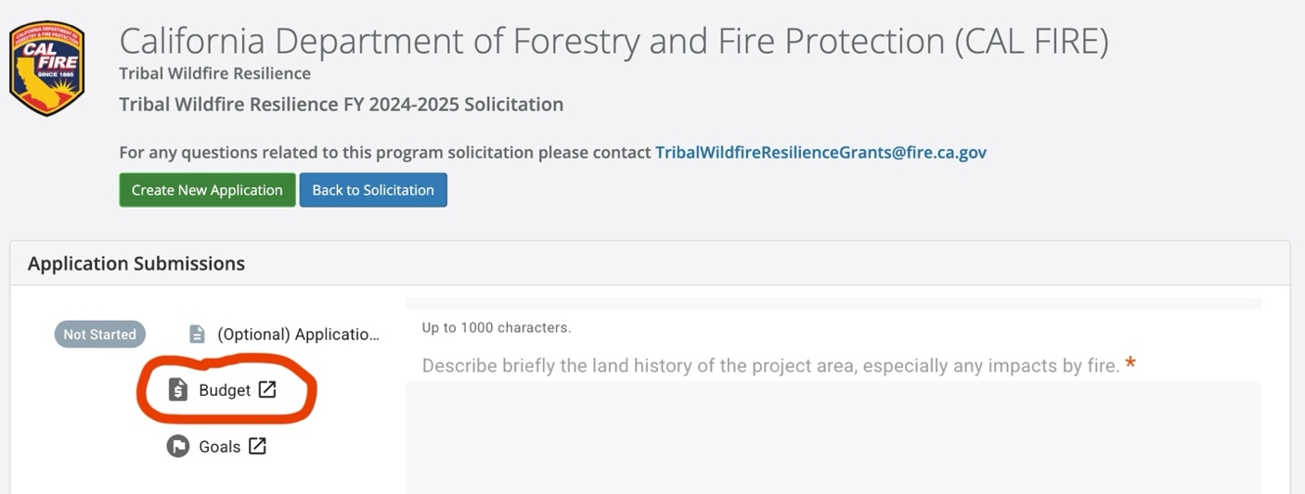

- The portal requires that users to input information into following fields: 1) Title; 2) Description; 3) Units; and 4) Unit Cost. Once you input this information, the Extended Cost AND Cost fields will calculate automatically.

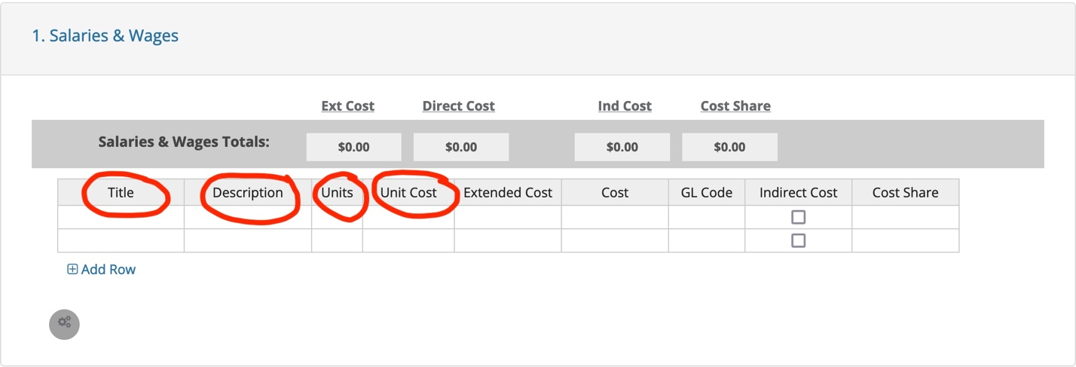

- Both the Extended Cost and Cost fields are calculated by multiplying the Units by the Unit Cost. This is the amount of grant funding requesting for this item.

- You need to clear all four of these fields if you need to re-enter the calculation.

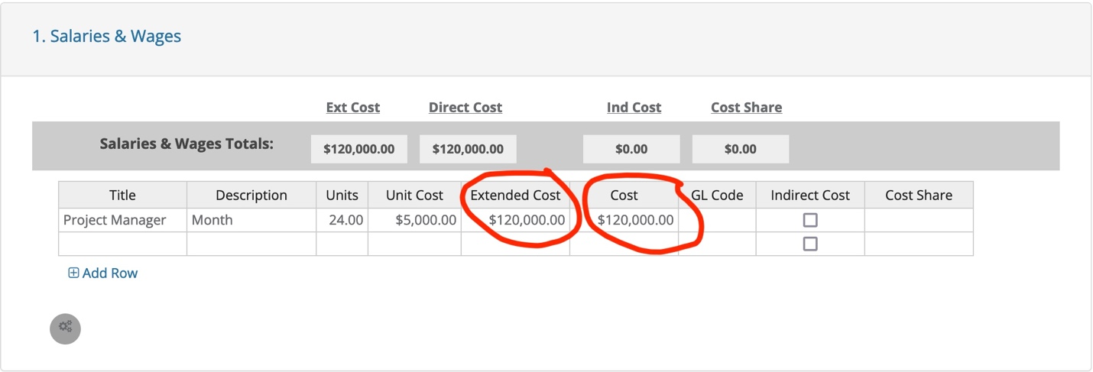

- The GL Code field is optional. Users may complete this field to assist in aligning the budget and subsequent reports with the General Ledger codes used in their accounting system.

- The Indirect and Cost Share fields should be used only if the project has budgeted indirect costs or cost share. In the example below, the Indirect and Cost Share fields have been filled in, meaning that indirect cost will be applied to this line item at the established rate. Please remember, Workforce development projects managed by non-profit grantees are the only project types eligible for indirect charges. Indirect charges must not exceed 12% for eligible projects unless an exemption is granted by CAL FIRE.

- Cost sharing (match) is required for many CAL FIRE grants. Please refer to the Funding Limits and Match Requirements table on page 7 of CAL FIRE’s FY2024-2025 Grant Guidelines to determine what, if any, cost share requirements apply to your application. In the e-Civis portal, the user must manually input amounts into the Cost Share field. The cost share amount for this example is equal to the direct cost amount (a 1:1 match), meaning that the user’s organization is committing $120,000 of matching funds over the life of the award, an amount equal to the funds being requested for CAL FIRE.

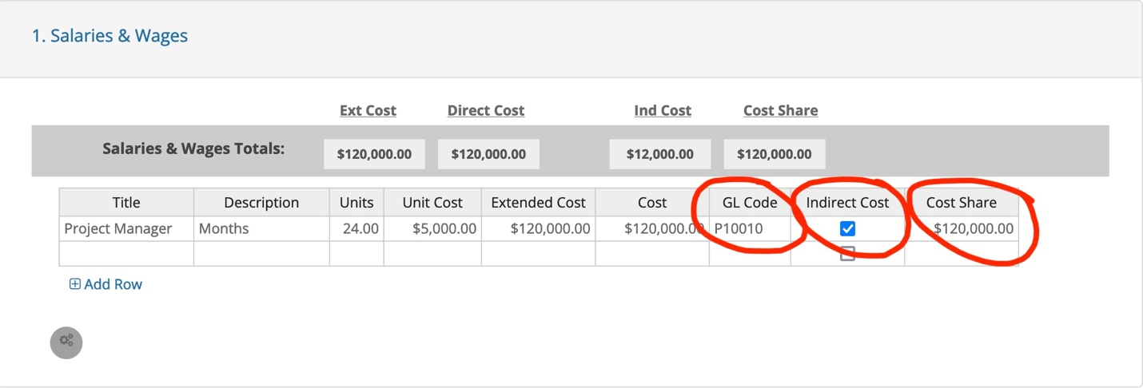

- After entering the budget line items, you must enter any projected income that will be generated during the life of the award. Your technical narrative and budget narrative should clearly articulate if and how any income will be reinvested in the project.

- Using the Detailed Budget, including the contents of the Budget Narrative column (AI), prepare a concise budget narrative in MS Word. The e-Civis portal allows 8,000 characters (with spaces) for the budget narrative. This equates to approximately three pages of singled spaced text using Times New Roman 12 font.

